Project:
Finished Goods Tracking System

Customer:
AISIN Automative Haryana Private Limited

Submitted By:


NOTICE
This document contains information, which is the proprietary property of SATO. This document is received in confidence and its contents cannot be disclosed or copied without the prior written consent of SATO.
Nothing in this document constitutes a guaranty, warranty, or license, express or implied. SATO disclaims all liability for all such guaranties, warranties, and licenses, including but not limited to: Fitness for a particular purpose; merchantability; not infringement of intellectual property or other rights of any third party or of SATO; indemnity; and all others. The reader is advised that third parties can have intellectual property rights that can be relevant to this document and the technologies discussed herein, and is advised to seek the advice of competent legal counsel, without obligation of SATO
SATO retains the right to make changes to this document at any time, without notice. SATO makes no warranty for the use of this document and assumes no responsibility for any errors that can appear in the document nor does it make a commitment to update the information contained herein.

COPYRIGHT
Copyright © SATO 2020. All rights reserved.

TRADEMARKS
*Other product and corporate names may be trademarks of other companies and are used only for explanation and to the owners' benefit, without intent to infringe.

Document History

Revision Number | Date | Prepared By | Comment
1.00 | 06-Jun-2021 | Akhilesh Kumar | Original Document

Acronym
Customer: AISIN Automative Haryana Private Limited hence forth will be referred as AISIN.
Vendor: Sato Argox India Pvt. Ltd., hence forth will be referred as SATO.

Contents

PROJECT SCOPE 6
Line wise Hardware & Software Configuration 7
Introduction 8
Login Screen 9
Main Menu 10
Master Management 12
Group Master 12
User Master 13
Part Master 14
Line Master 15
Location Master 16
Customer Master 17
Process 18
Production – Door Lock Lines(5) 18
Production – AEP Application – Other Lines(12) 20
Reprint – Door Lock Lines(5) 21
Login(HHT) 23
Main Menu(HHT) 24
Rejection With Part Barcode – Door Lock Lines(HHT) 25
Rejection WithOut Part Barcode – Other Lines(HHT) 26
Fraction With Part Barcode – Door Lock Lines(HHT) 27
Fraction WithOut Part Barcode – Other Lines(HHT) 28
FG Feeding(HHT) 29
Upload PickList(Dekstop App) 30
FG Picking(HHT) 31
Direct Dispatch(HHT) 32
Loading List(Desktop App) 33
After Picking Dispatch(HHT) 34

PROJECT SCOPE
The scope of the solution is to equip users with FG Tracking System which can print barcode label and manage other operation. This would require the development of the desktop application, AEP application, device application & middleware application.
The entire solution consists of followings:
- Front-End Application – Desktop Application
- Mobile Device Application

The solution will work on client server environment; the data will be stored at data server.

Line wise Hardware & Software Configuration
Line Count | Description | Hardware
5 | Door Lock | - All the 5 lines will have 5 barcode printer and 5 Industrial PC and 5 USB Scanner.  - PC will be connected to the network through LAN cable.  - All the scanner will be connected to PC through USB Cable  - All the printer will be connected to PC through USB Cable.  Desktop Application will be installed on the PC
7 | Handle | - 5 Printer and 5 USB Scanner.  - All the printers will be connected to the network through LAN Cable.  - Scanner will be connected to the Printer through USB Cable.  AEP Application will be installed on the printer which will run inside the printer.
1 | RQC | - 1 Printer and 1 USB Scanner.  - The printer will be connected to the network through LAN Cable.  - Scanner will be connected to the Printer through USB Cable.  AEP Application will be installed on the printer which will run inside the printer.
1 | Pass through products | - 1 Printer and 1 USB Scanner.  - The printer will be connected to the network through LAN Cable.  - Scanner will be connected to the Printer through USB Cable.  AEP Application will be installed on the printer which will run inside the printer.
3 | Small Lines | - 3 Printer and 3 USB Scanner.  - All the printers will be connected to the network through LAN Cable.  - Scanner will be connected to the Printer through USB Cable.  AEP Application will be installed on the printer which will run inside the printer.
Total Line : 17 | Total Printing Station : 15 | 15 Printer + 15 Scanner + 5 PC

Introduction
The scope of this document is to provide the understanding of this solution to all members of AISIN Team & SATO Team associated with the solution development & implementation.
This document major emphasize on solution processes & user operations, where the data will be captured and afterwards will be used.
This solution major comprises of followings:
- Master Managements
- Different Types of Processes.

Desktop App For Door Lock Lines(5) & Other System

Login Screen
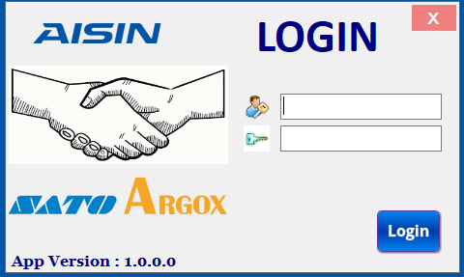

Brief Description: This screen is used for login purpose. User will enter User id & Password; system will validate entered user id & password. On the basis of entered user id & user rights assigned to user, menus of Main Menu screen will be enabled.

Main Menu
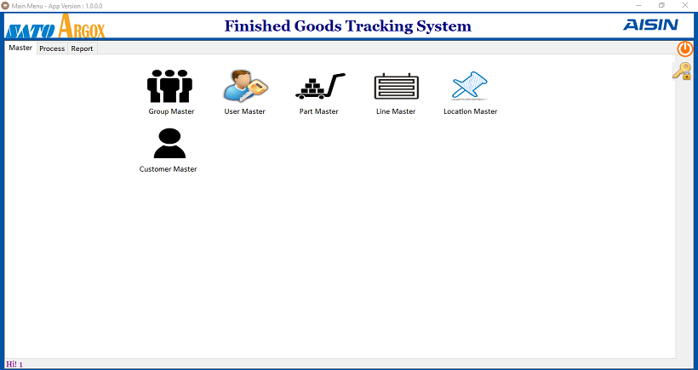

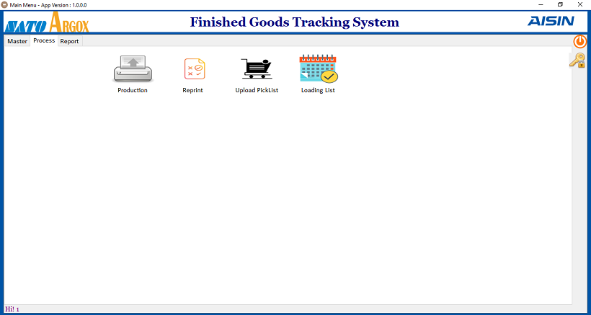

Brief Description: Main menu has three category.
Master – By clicking on relative master menu user can navigate to different screen, like as user will click on User Master it will take to user master screen.

Process – By clicking on relative process menu user can navigate to different process screen.

Report – By clicking on relative report menu user can navigate to different report screen.

Master Management

Group Master
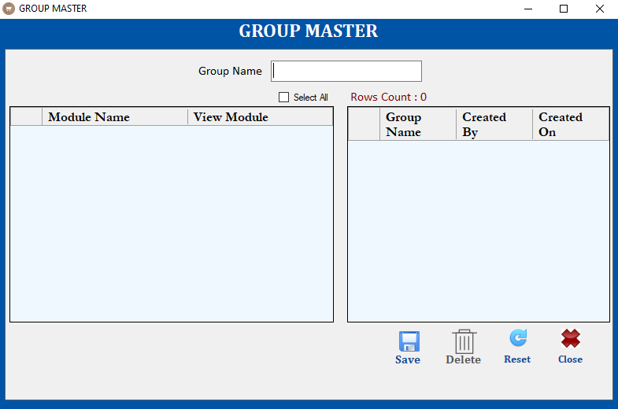

Brief Description: This screen is used to manage Group via Save, Delete operations.
Note: GroupName Will Be Unique(Group will be used to manage user access rights).
Function Description in Detail:

Sr.No. | Function | Description | Remarks
1. | FORM LOAD | →During Form Load all data will be loaded in the Grid
2. | SAVE | →User will enter group name and select all the screen for which group has right and click on save button to save the data.  →User will double click on any item in the grid to edit the data and click on save button to update the data.
3. | Delete | →User will double click on any item in the grid to select the data and click on delete button to delete the data.
4. | ReSet | →It will clear all fields.

User Master
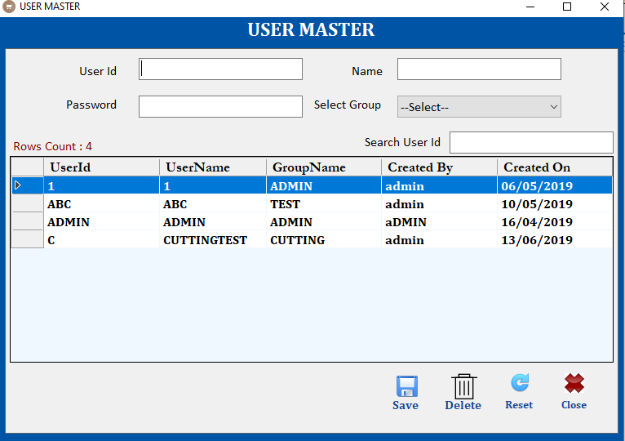

Brief Description: This screen is used to manage User via Save, Delete operations.
Note: UserId Will Be Unique.
Function Description in Detail:

Sr.No. | Function | Description | Remarks
1. | FORM LOAD | →During Form Load all data will be loaded in the Grid
2. | SAVE | →User will enter all details and click on save button to save the data.  →User will double click on any item in the grid to edit the data and click on save button to update the data.
3. | Delete | →User will double click on any item in the grid to select the data and click on delete button to delete the data.
4. | ReSet | →It will clear all fields.

Part Master
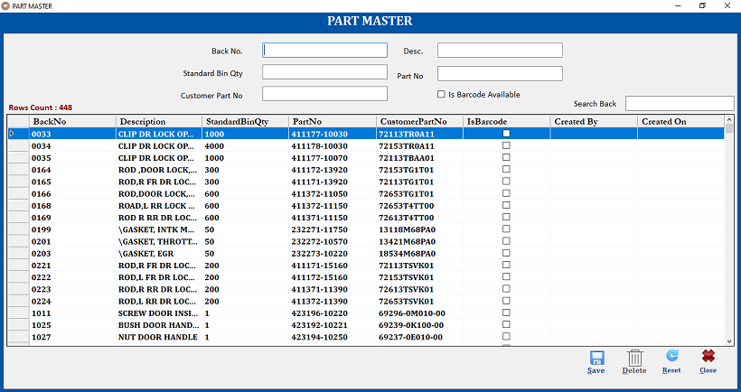

Brief Description: This screen is used to manage Part via Save, Delete operations.
Note: Back No Will Be Unique.
Function Description in Detail:

Sr.No. | Function | Description | Remarks
1. | FORM LOAD | →During Form Load all data will be loaded in the Grid
2. | SAVE | →User will enter all details and click on save button to save the data.  →User will double click on any item in the grid to edit the data and click on save button to update the data.
3. | Delete | →User will double click on any item in the grid to select the data and click on delete button to delete the data.
4. | ReSet | →It will clear all fields.

Line Master
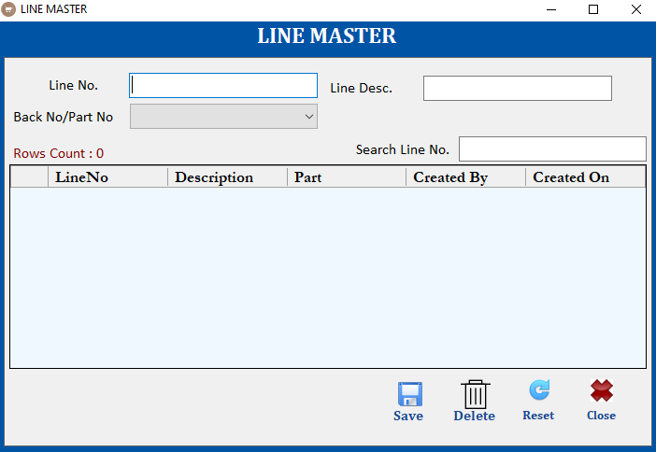

Brief Description: This screen is used to manage Line via Save, Delete operations.
Note: Line No Will Be Unique. Line will be mapped to Back No which is optional(mainly used for those lines where AEP application will run)
Function Description in Detail:

Sr.No. | Function | Description | Remarks
1. | FORM LOAD | →During Form Load all data will be loaded in the Grid
2. | SAVE | →User will enter all details and click on save button to save the data.  →User will double click on any item in the grid to edit the data and click on save button to update the data.
3. | Delete | →User will double click on any item in the grid to select the data and click on delete button to delete the data.
4. | ReSet | →It will clear all fields.

Location Master
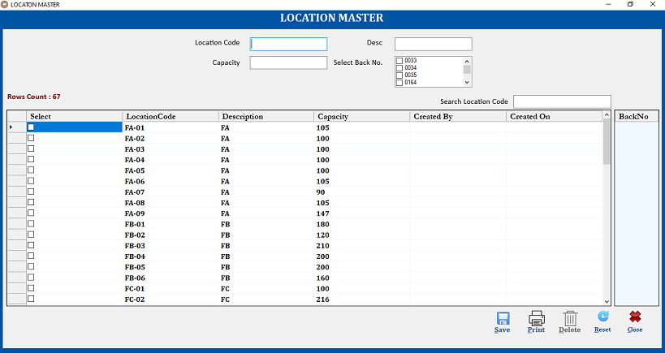

Brief Description: This screen is used to manage Location via Save, Delete operations.
Note: Location Code Will Be Unique. One location can be mapped to multiple Part
Function Description in Detail:

Sr.No. | Function | Description | Remarks
1. | FORM LOAD | →During Form Load all data will be loaded in the Grid
2. | SAVE | →User will enter all details and click on save button to save the data.  →User will double click on any item in the grid to edit the data and click on save button to update the data.
3. | Print | →If user want to print barcode for any location code. Then user can select the location and click on print button to print the barcode.
4. | Delete | →User will double click on any item in the grid to select the data and click on delete button to delete the data.
5. | ReSet | →It will clear all fields.

Customer Master
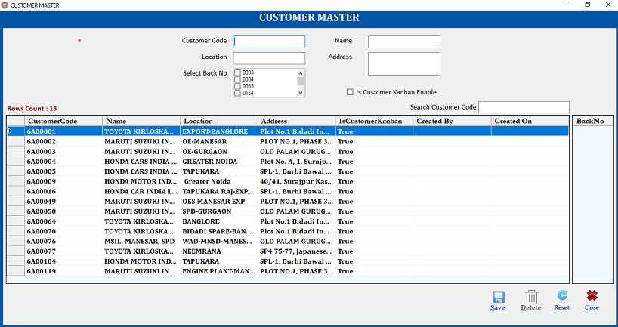

Brief Description: This screen is used to manage Customer via Save, Delete operations.
Note: Customer Code Will Be Unique. One Customer can be mapped to multiple Back No. Currently Maruti & Honda Export Kanban is not scannable so “Is Customer Kanban Enable” will be unchecked.
Function Description in Detail:

Sr.No. | Function | Description | Remarks
1. | FORM LOAD | →During Form Load all data will be loaded in the Grid
2. | SAVE | →User will enter all details and click on save button to save the data.  →User will double click on any item in the grid to edit the data and click on save button to update the data.
3. | Delete | →User will double click on any item in the grid to select the data and click on delete button to delete the data.
4. | ReSet | →It will clear all fields.

Process

Production – Door Lock Lines(5)

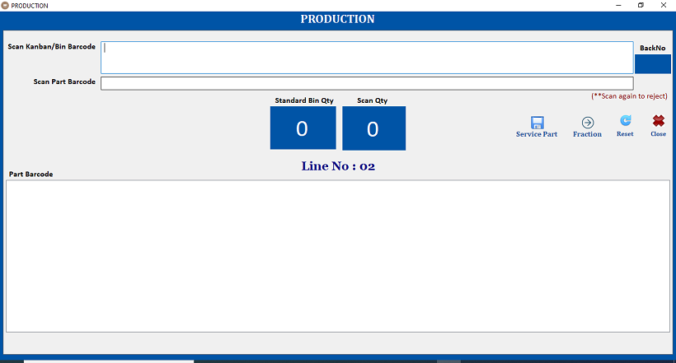

Brief Description: Following operations will be performed on this screen.
- User will scan Kanban Barcode.
- There are two types of Kanban one is for Domestic & second is For Export.
- Data format of both Kanban will be same.
- Standard Bin Qty will come automatically from the Part Master based on the scanned Kanban Barcode Back No.
- User Will scan the Part Barcode.
- Part Barcode will be unique for all types of Kanban.
- Last 4 digit of all the part barcode will have back no.

- Scan Qty will be increased automatically.
- User will start the QA process.
- After QA if part is rejected then user will scan the same part barcode to reject the part. Application will ask for the confirmation for rejected part. If user click on yes button then part will be rejected and scan qty will be decreased automatically.
- User will repeat the same process for scanning other part barcode, when standard bin qty will be equal to scan qty a new Bin Barcode will be generated automatically and all the fields will be reset.
- Label Size is 20X20 mm.
- Label will have one QR Barcode.
- Barcode will be always unique and contents of the barcode will be like 21012011203116PART.
- Barcode length will be 18
- 6 Digit Date Month Year(ddMMyy).
- 6 Digit Time(HHmmss)
- 2 Digit Line No
- 4 Digit Part No

- If the rejected part is the last part, in that case bin barcode is already generated so user will scan the bin barcode.
- Standard Bin Qty and scan qty will come automatically.
- User will scan the part barcode to reject the part.
- User will scan the new part barcode to complete the bin.
- In this case new bin barcode will not generated, application will show the message bin competed.
- If user want to generate any fraction bin, then user will click on the Fraction button to print the bin barcode.
- If user want to generate any bin for service part then user will click on spare part button to print the bin barcode.

Production – AEP Application – Other Lines(12)

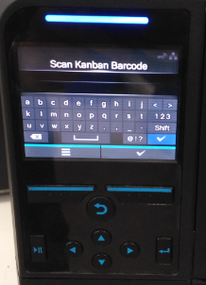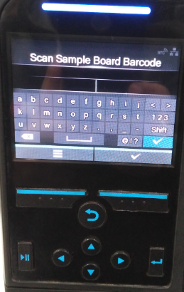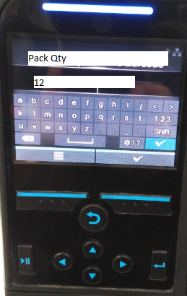

Brief Description: AEP application will run inside the printer.
- User will scan the Kanban Barcode.
- Then another screen will come automatically which will ask to scan Sample Board Barcode.
- Sample Board Barcode will be same as Kanban.
- Back No from the Kanban and sample board barcode will be checked. If back no are same then another screen will come which will show bin standard qty of the back no.
- User can edit the qty in case of fraction bin.
- User will click the ok button in the printer to print the Bin Barcode.

Reprint – Door Lock Lines(5)

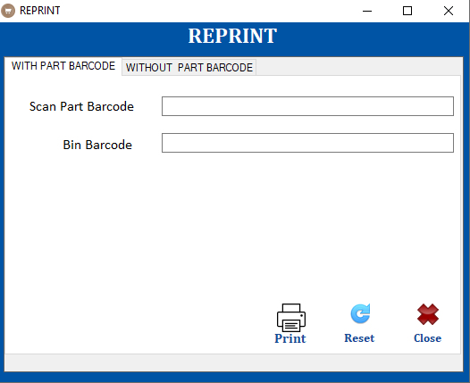

Brief Description: If due to some reason user need to reprint the bin barcode then Reprint screen will be used. It has two options one for door lock lines(With Part Barcode) and other is for other Lines(WithOut part Barcode).

With Part Barcode Option (Door Lock Lines): Following steps will be performed.
- User will scan any part barcode from the bin.
- Bin barcode will come automatically.
- User will click on the print button to print the bin barcode.
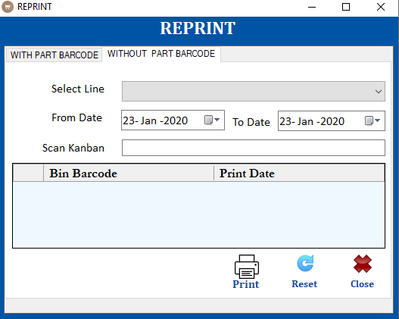

WithOut Part Barcode Option (Other Lines): Following steps will be performed.
- User will select the line.
- Use will select the date.
- User will scan the Kanban.
- Based on the selected Kanban all bin barcode with print date will come in the grid.
- User will select any bin barcode from the grid and click on print button to print the bin barcode.

Login(HHT)

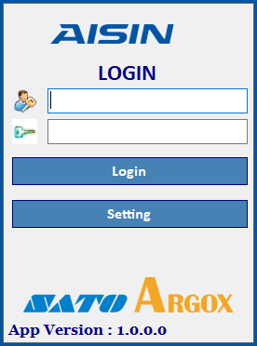

Brief Description: This screen will be used to login in HHT, based on user rights menu will be enable/disable for the user.

Main Menu(HHT)

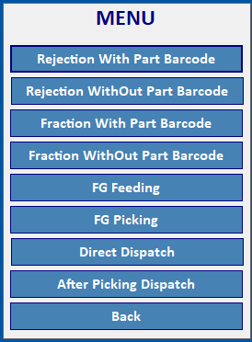

Brief Description: This screen will be used to select different operations in the HHT.

Rejection With Part Barcode – Door Lock Lines(HHT)

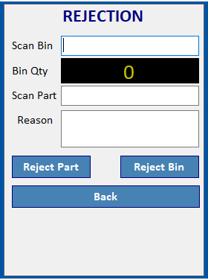

Brief Description: User can reject any part in HHT also. Following steps will be used.
- If user want to reject the complete bin then user will scan the bin barcode.
- Qty of the bin will come automatically.
- User has to specify the reason for the rejection.
- Click on Reject Bin button to reject the complete bin.
- If user want to reject only part then scan the part barcode.
- Specify the reason for the rejection.
- Click on Reject Part button.

Rejection WithOut Part Barcode – Other Lines(HHT)
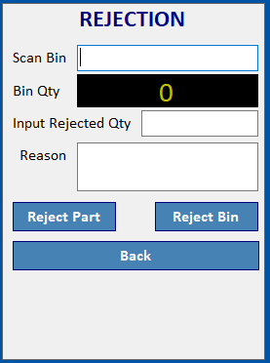

Brief Description: Following steps will be used.
- If user want to reject the complete bin then user will scan the bin barcode.
- Qty of the bin will come automatically.
- User has to specify the reason for the rejection.
- Click on Reject Bin button to reject the complete bin.
- If user want to reject only part then scan the Bin barcode.
- Qty of the bin will come automatically.
- Input the rejected qty.
- Specify the reason for the rejection.
- Click on Reject Part button.

Fraction With Part Barcode – Door Lock Lines(HHT)

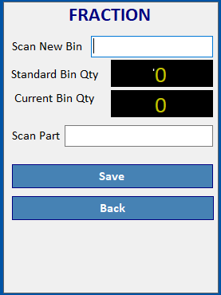

Brief Description: If any part is rejected due to any reason and user want to add new part from the fraction bin then user will follow the following steps.
- Since bin has already bin barcode so user will scan the new bin barcode.
- Standard Bin Qty and Current Bin Qty will be fetched automatically.
- User scan the part barcode from the fraction bin.
- User will click the save button to add scanned part into new bin.

Fraction WithOut Part Barcode – Other Lines(HHT)

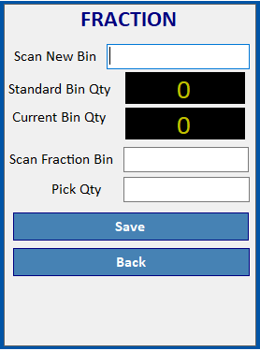

Brief Description: If any part is rejected due to any reason and user want to add new part from the fraction bin then user will follow the following steps.
- Since bin has already bin barcode so user will scan the new bin barcode.
- Standard Bin Qty and Current Bin Qty will be fetched automatically.
- User will scan the fraction bin barcode.
- User will input the qty to be picked from the fraction bin.
- User will click the save button to add part into new bin.

FG Feeding(HHT)
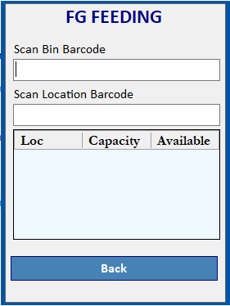
Brief Description: User will follow the following steps.
- Scan the bin barcode.
- Since part is already mapped to location so suggested locations along with the capacity & Available capacity will come automatically.
- User will go to the one of the suggested location.
- User will scan the location barcode.
- If location has space(as per capacity) then app will allow the user to put the bin on scanned location.

Upload PickList(Dekstop App)
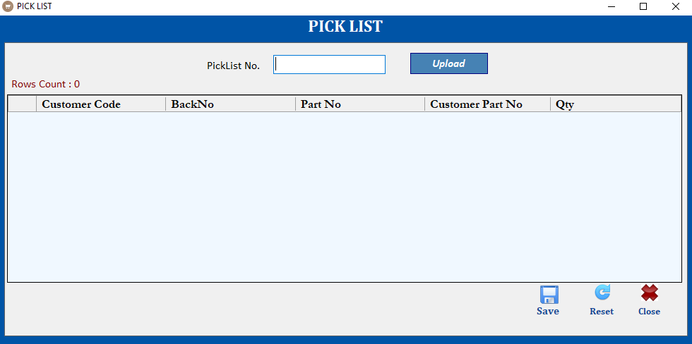

Brief Description: This screen will be used to upload the picklist file.
- Application will generate the unique picklist no. automatically.
- PickList No. format will be like ddMMyy-0001
- 6 Digit Date Month Year and last 4 digit will be auto increment serial no.
- User will click on upload button to select the excel picklist file.
- Excel file will have Customer Code, Back No, Part No, Customer Part No and Qty(Bin Qty)
- Application will read all the data from the selected excel file and load it into the grid.
- User will click on save button to save the selected file data against the picklist no.

Note: After saved successfully, application will show the picklist no. again. User should note down the picklist no. Same picklist no will be used for further picking and dispatch operation.

FG Picking(HHT)
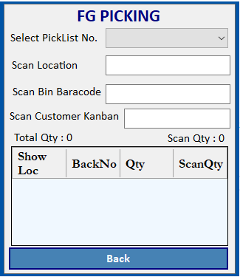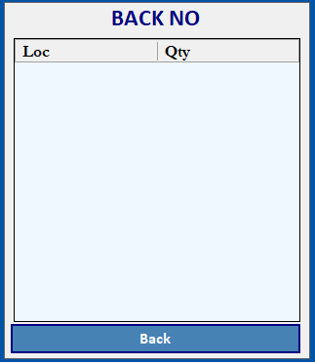

Brief Description: User will follow the following steps.
- User will select the picklist no.
- As per selected picklist no app will show the Total Qty & Scan Qty of the picklist. All the back no. wise details will be loaded in the grid.
- If user want to see the location of particular back no then user will click on the show location button. It will open the new screen which will show the back no. wise location and qty as per FIFO.
- User will scan the location barcode.
- User will scan the bin barcode.
- User will scan the customer Kanban barcode.
- There are four types of customer Kanban.
- Honda Export
- Toyota
- Maruti
- Honda Domestic
- Currently Honda Domestic Kanban barcode does not have part no & Maruti Kanban barcode is not scannable.
- Application will identify the customer Kanban based on barcode data length.
- Customer Kanban field will be disable if in customer master “Is Customer Kanban Available” field is not selected for the customer. Currently this field will be enable only for Honda Export & Toyota.
- App will validate the Back no from the Customer Kanban with PickList and bin barcode.
- If all the validations are successful then data will be saved other wise user will get the relevant message.

Direct Dispatch(HHT)
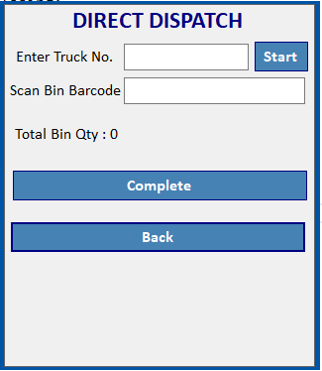

Brief Description: If use wants to send bin directly to warehouse or some customer without feeding & picking then this screen will be used.

- User will input the truck no and click on start button to start the process.
- User will scan the bin barcode.
- Bin qty will be increased automatically after every bin scanning.
- Once operation will complete then user will click on the complete button.

Loading List(Desktop App)
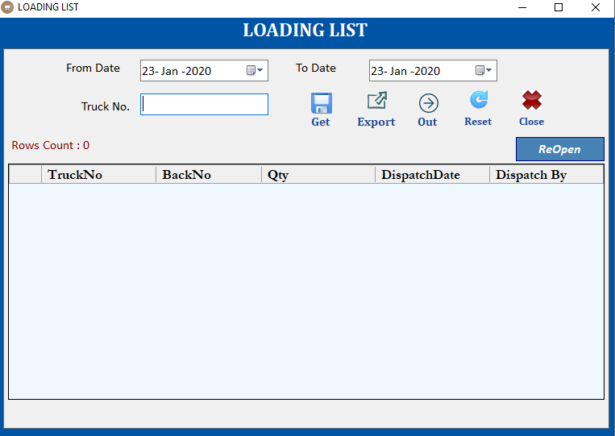

Brief Description: After direct dispatch from the device user can use this screen to see the details.

- User will select the date and input the truck no then click on get button to fetch the relevant details.
- All the details will be loaded into the grid.
- User will click on export button to export the data from the grid to excel file or csv file.
- User will click on out button so that same truck no. can be used for direct dispatch again after completing the truck no.
- If user by accident click on complete button in the HHT then user has to click on ReOpen the button to reopen the same truck no.

After Picking Dispatch(HHT)
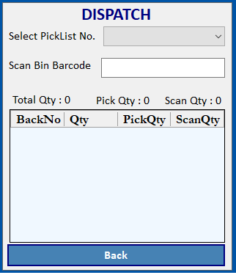

Brief Description: If use wants to dispatch the bin after picking then this screen will be used.

- User will select the picklist no.
- All the details will come automatically as per selected picklist no.
- User will scan the bin barcode to verify the dispatch.
- Scan qty will be increased automatically.

NOTE:
- Screen design may change, above are reference screens.
- In HHT for every error there will be sound and vibration.

.

